Function Call
A function definition does nothing by itself. To use a function we must call it. The syntax of calling a function is as follows:
function_name(arg1, arg2, arg3, ... argN)
If function doesn't accept any arguments then use the following syntax:
function_name()
The following code calls greet() function:
greet() # calling greet() function
python101/Chapter-13/calling_first_function.py
1  2  3  4  5  6  7 | import datetime  def greet():  print("Hello !")  print("Today is", datetime.datetime.now())  greet()
Try it now
Output:
1  2 | Hello !  Today is 2017-06-20 13:20:45.281651
The function call must appear after the function is defined otherwise, you will encounter NameError exception. For example:
python101/Chapter-13/call_before_definition.py
1  2  3  4  5  6  7 | import datetime  greet() ## ERROR: trying to call greet() before its defined  def greet():  print("Hello !")  print("Today is", datetime.datetime.now())
Try it now
Output:
1  2  3  4  5 | q@vm:~/python101/Chapter-13$ python call_before_definition.py  Traceback (most recent call last):  File "call_before_definition.py", line 3, in <module>  greet() ## ERROR: trying to call greet() before its defined  NameError: name 'greet' is not defined
When a function is called the program control jumps to that function definition and executes the statements inside the function body. After executing the body of the function, the program control jumps back to the part of the program which called the function, and resumes execution at that point.
The following example demonstrates what happens when a function is called.
python101/Chapter-13/transfer_of_control.py
1  2  3  4  5  6  7  8  9 | import datetime  def greet():  print("Hello !")  print("Today is", datetime.datetime.now())  print("Before calling greet()")  greet()  print("After calling greet()")
Try it now
Output:
1  2  3  4 | Before calling greet()  Hello !  Today is 2017-06-20 13:20:45.281651  After calling greet()
In lines 3-5, we have defined a greet() statement. The print() statement in line 7, prints string "Before calling greet()" to the console. In line 8, we are calling greet() function. At this point, the execution of statements following the call to greet() halts and program control jumps to the definition of the greet() function. After executing the body of the greet() function program control again jumps back to the point where it left off and resumes the execution from there.
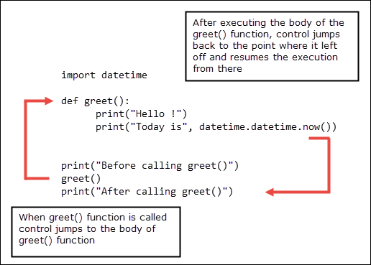
Our previous program has only function. It is not unusual for programs to have hundreds or even thousands of functions. In python, it a common convention to define a function called main() which gets called when the program start. This main() function then goes on to call other function as needed. The following program demonstrates flow of program control when we have two functions in a program.
python101/Chapter-13/two_func_program_control.py
1  2  3  4  5  6  7  8  9  10  11  12  13 | import datetime  def greet(name):  print("Hello", name, "!")  print("Today is", datetime.datetime.now())  def main():  print("main() function called")  greet("Jon")  print("main() function finished")  main()
Try it now
In lines 3-5, and 8-11, we have defined two functions greet() and main(). The greet() function is now updated to accept an argument called name, which it then uses in the next line to greet the user.
The main() function doesn't accept any arguments and has three statements inside the body.
The statement in line 13, calls the main() function. The program control jumps to the body of the main() function. The first statement inside the main() prints string "main() function called" to the console. The statement in line 10, calls the greet() function with an argument "Jon" which will be assigned to the variable name in the function header. At this point, execution of statements following call to greet() halts and program control jumps to the body of the greet() function. After executing the body of the greet() function, program control jumps back to where it left off and executes the print() statement in line 11. As there are no more statements left to execute in the main() function and program control jumps again back to where it left off to execute statements after the function call (line 13).

